DEPARTMENT OF COMPUTER SCIENCE & ENGINEERING
ABES Engineering College,Ghaziabad
SOFTWARE REQUIREMENTS
SPECIFICATION (SRS)
Project Title: Credit Card Fraud Rule Engine (Project ID: P_151)
————————————————————————————
SUBMITTED BY:  Esha Sarswat(Roll No: 2400320100457)  Degree: Bachelor of Technology (B.Tech)  Academic Year: 2026 - 2027 | UNDER THE GUIDANCE OF:  Prof. / Dr. Varsha Saxena  Mentor  Department of Computer Science & Engg.  Status: 3rd Year Project Specification  Date of Submission: 1-10-2006

Document Revision & Approval History
fVersion | Date | DescriptionMajor Changes | Reviewed Byby
0.1 | 15-Sep-2026 | Initial Draft & Scope Definition | Project Guide
1.0 | 30-Sep-2026 | Final 3rd Year Mid-Term SRS Baseline | HOD / Committee

1. Introduction
1.1 Purpose
The purpose of this Software Requirements Specification (SRS) document is to provide a complete, clear, and unambiguous definition of the functionality, external interfaces, performance targets, and constraints of the proposed system: 'Credit Card Fraud Rule Engine'. This specification serves as a binding reference agreement between student developers, project evaluators, academic supervisors, and prospective end users during the 3rd-year engineering curriculum.
The system detects, flags and prevents fraudulent credit card transactions in real time by evaluating each transaction against a configurable, analyst-managed set of business rules. It produces a composite risk score and an explainable approve / review / decline decision, routes flagged transactions into a case-management workflow, and keeps a complete audit trail. This document is intended for the project team, the supervising faculty and evaluators, and the prospective administrators and fraud analysts of the system.
1.2 Scope of the System
The proposed application is designed to solve the problem of detecting and preventing fraudulent credit card transactions in real time while keeping every decision transparent, explainable and auditable (as opposed to a black-box ML model) by delivering an end-to-end rule-based platform. Key boundary guidelines include:
- In-Scope Capabilities: Real-time transaction ingestion and validation through a REST API; a runtime-configurable rule engine (VELOCITY, GEOLOCATION, AMOUNT_THRESHOLD, MCC, DEVICE, BEHAVIORAL and BLACKLIST rules) with weighted composite risk scoring; approve / review / decline decisions; a fraud case-management workflow; JWT authentication with role-based access (Admin, Analyst, Viewer); dashboards, reports and an immutable audit trail; a Streamlit web interface for all roles.
- Out-of-Scope Boundaries: Live commercial payment processing and real card-network integration (a transaction simulator / sandbox feed is used); storage of full card numbers (PAN) or CVV; machine-learning scoring, graph-based fraud-ring detection, adaptive rule weights, multi-currency compliance logic and a customer mobile app (listed as future scope); step-up authentication challenges (UNDER_REVIEW is used instead); hardware fabrication.
- Expected Benefits: Reduced financial loss from fraudulent transactions; transparent decisions in which every outcome traces to the specific rules that triggered; fraud analysts can create, tune and disable rules without code changes or redeployment; fewer false positives through weighted composite scoring instead of single-rule blocking; a complete audit trail for compliance and reporting.
1.3 Definitions, Acronyms, and Abbreviations
Category | Term / Acronym | Definition / Standard Context
Standard | SRS | Software Requirements Specification (IEEE Std 830-1998 format).
Architecture | API | Application Programming Interface for data interchange via JSON/HTTPS.
Security | JWT / RBAC | JSON Web Token for stateless authorization; Role-Based Access Control (ADMIN / ANALYST / VIEWER).
Database | CRUD | Create, Read, Update, Delete basic data manipulation operations.
Network | REST | Representational State Transfer stateless software architectural style.
Project Specific | PAN | Primary Account Number (the full card number). Never stored by this system; only masked or tokenized references are kept.
Project Specific | PCI-DSS | Payment Card Industry Data Security Standard; the project follows its practices (alignment, not formal certification).
Project Specific | MCC | Merchant Category Code classifying a merchant's line of business; used by MCC rules.
Project Specific | Rule Expression | Condition logic of a rule, stored as JSON/text in the rules table and interpreted by the rule evaluator.
Project Specific | Velocity Rule | A rule that counts transactions or sums amounts for a card, device or IP address within a time window.
Project Specific | Risk Score | Sum of the weights of all rules triggered by a transaction; drives the approve / review / decline decision.
Project Specific | False Positive | A legitimate transaction wrongly flagged as fraud (fraud case closed as CLOSED_LEGITIMATE).
Project Specific | Fraud Case | Record created for a flagged transaction so that an analyst can investigate and resolve it.
Project Specific | ORM | Object-Relational Mapping; SQLAlchemy maps Python classes to database tables.
Project Specific | TDE | Transparent Data Encryption (database-level encryption at rest).
Project Specific | RTO / RPO | Recovery Time Objective / Recovery Point Objective for disaster recovery.
Project Specific | FastAPI / Streamlit | Python web framework for the backend REST API / Python framework for the all-Python frontend.
Project Specific | Kafka | Apache Kafka distributed event-streaming platform (optional real-time ingestion channel).
1.4 References
- IEEE Std 830-1998: IEEE Recommended Practice for Software Requirements Specifications.
- Software Engineering (10th Edition): Ian Sommerville, Pearson Education.
- Relevant Research Papers & APIs: Official documentation of FastAPI, Streamlit, SQLAlchemy, Alembic and Pydantic; PCI Security Standards Council, PCI DSS (v4.x) requirements; IETF RFC 7519 (JSON Web Token); OWASP Top 10 and API Security Top 10; MySQL / PostgreSQL documentation; Apache Kafka documentation (optional streaming channel).
- Project Synopsis: P_151 – Credit Card Fraud Rule Engine, Project Documentation (technology stack, database schema, architecture, data protection and novelty).
1.5 Document Overview
The remainder of this SRS is partitioned into structural sections: Section 2 outlines the product perspective, user classes, operating environment, constraints and assumptions. Section 3 itemizes the detailed functional requirements, organized into seven modules (authentication, transaction ingestion, rule management, rule evaluation and scoring, case management, reporting, and audit/administration). Section 4 specifies external interfaces (UI, Hardware, Software, Communication). Section 5 defines non-functional attributes (Performance, Security, Reliability, Integrity, Usability, Maintainability, Scalability, Portability). Section 6 provides the analysis models (use case, DFD, ERD, sequence). Section 7 records the academic review and sign-off.
2. Overall Description
2.1 Product Perspective
The Credit Card Fraud Rule Engine is a new, self-contained, layered (N-tier) web system: a Streamlit presentation layer, a FastAPI application tier (Control, Service, Repository and Entity layers) and a relational MySQL/PostgreSQL database. It receives transaction events from an upstream transaction source (a payment-gateway feed or, in this project, a transaction simulator / sandbox feed) and returns an approve / review / decline decision. The Streamlit frontend talks to the backend only through authenticated RESTful JSON APIs over HTTPS. The rule engine runs in-process inside the service layer; it may optionally be externalized as a separate rule-evaluation service, and transactions may optionally arrive through an Apache Kafka topic. Figure 2.1 shows the system context (DFD Level 0).
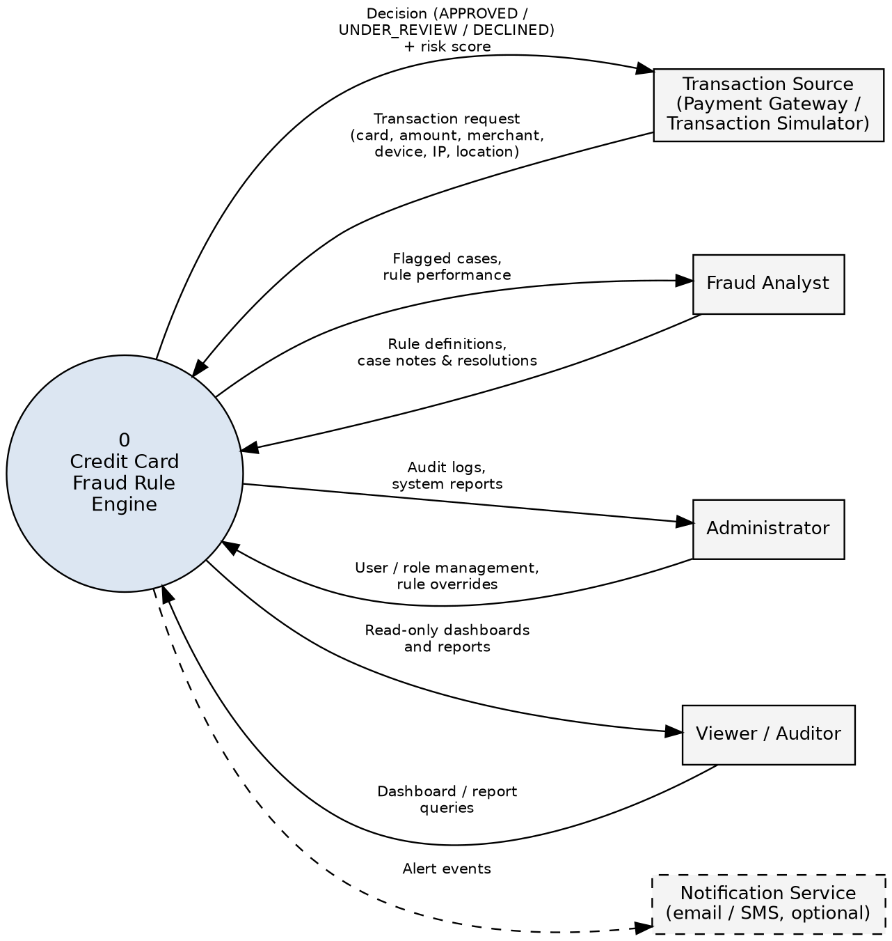
Figure 2.1: System Context Diagram (DFD Level 0)

2.2 User Classes and Characteristics
The system supports three human user classes, enforced through role-based access control (users.role = ADMIN / ANALYST / VIEWER), plus one external system actor. There is no guest or public access: every endpoint except login requires authentication. Privileges are cumulative (Viewer ⊂ Analyst ⊂ Administrator).
User Role / Persona | Technical Proficiency | Core Responsibilities & Rights
System Administrator | High (system administration, database and deployment familiarity) | All Analyst privileges plus: create, modify and deactivate user accounts and roles; view the complete audit log; reassign fraud cases; configure decision thresholds.
Fraud Analyst | Intermediate to High (fraud-domain knowledge; no programming required) | Create, edit, enable/disable and prioritize rules; view transactions and rule-evaluation details; work assigned fraud cases (add notes, resolve as CLOSED_FRAUD or CLOSED_LEGITIMATE); view dashboards and rule-performance reports.
Viewer / Auditor | Basic to Intermediate | Read-only access to dashboards, transactions, transaction detail and reports. Cannot modify rules, cases or users.
Transaction Source (external system) | Not applicable (automated client) | Submits transaction events to the ingestion API using a service credential and receives the decision and risk score.
2.3 Operating Environment
The application operates within the following software and hardware environments:
- Client Requirements: Modern web browser (Google Chrome ≥ v110, Mozilla Firefox ≥ v108, Edge, Safari) to use the Streamlit UI; minimum display resolution 1366x768. The UI is optimized for desktop use.
- Server Runtime Environment: Linux (Ubuntu 22.04 LTS / Debian 12) or Windows Server; Python 3.10+; FastAPI served by Uvicorn (optionally behind Gunicorn); Docker containers hosted on a cloud platform (AWS / Azure / GCP) or an on-premise server.
- Database Storage Tier: PostgreSQL 15 or MySQL 8.0 (ACID-compliant RDBMS) accessed through SQLAlchemy; optional Apache Kafka broker for streaming ingestion.
2.4 Design and Implementation Constraints
- Academic Budget Constraint: Free-tier cloud resources or local containerized hosting; open-source stack only; fixed academic timeline and team size. Optional components (Kafka, ELK stack, email/SMS notification) are implemented only if time permits.
- Security Compliance: Passwords stored only as salted BCrypt hashes; full PAN and CVV never stored (masked card numbers or tokens only); all external traffic over HTTPS/TLS; secrets kept in environment variables or a secrets manager; PCI-DSS-aligned practices; JWT tokens are short-lived and can be invalidated on logout (FR-1.5).
- Modularity Standards: Layered architecture (Control → Service → Repository → Entity) with Pydantic DTOs; business logic only in the service layer; schema changes through Alembic migrations; rule logic stored as data and interpreted by a safe evaluator, never executed with eval().
- Real-Time Constraint: Decisions are returned synchronously to the caller within the latency target of Section 5.1, so rule evaluation is limited to indexed look-ups and bounded time windows.
2.5 Assumptions and Dependencies
- Assumptions: Network connectivity between all tiers is reliable; server and database clocks are NTP-synchronized (velocity and time-window rules depend on transaction_time); the transaction source supplies card reference, amount, currency, merchant, time, location, device fingerprint and IP address, and provides a masked or tokenized card reference rather than a full PAN; card, customer and merchant master data exist in the database before scoring; geolocation rules use the location supplied in the event (no external geocoding service); project data is synthetic or anonymized.
- Dependencies: Python packages (FastAPI, Uvicorn, SQLAlchemy, Alembic, Pydantic, PyJWT / python-jose, BCrypt, Streamlit, httpx / requests, pytest); a MySQL or PostgreSQL server. Optional: Apache Kafka (aiokafka / confluent-kafka-python), ELK stack, email/SMS notification service, and payment-gateway / card-network feeds.
- Decision Thresholds: A composite score below the review threshold gives APPROVED; a score from the review threshold up to the decline threshold gives UNDER_REVIEW; a score at or above the decline threshold gives DECLINED. Default values are configurable and will be calibrated during testing.
- Schema Extensions: Requirements analysis shows the synopsis schema needs minor additions: a rule priority field, a users active flag, storage for decision thresholds, and an idempotency key on transactions. They are assumed by the requirements in Section 3.
3. System Features and Functional Requirements
Requirements are categorized by functional subsystem modules with unique requirement identifiers (FR-x.x). Priority: High = essential for the baseline system; Medium = important but deferrable; Low = optional, implemented if time permits. Capabilities the synopsis marks as optional (Kafka streaming, customer notification) are rated Low.
3.1 Module 1: Authentication and Access Governance
Req ID | Feature Description | Input / Validation Rule | Priority
FR-1.1 | User Account Creation (by Administrator only; no public self-registration) | username (unique), email (valid format), password (≥ 8 chars, alphanumeric + symbol), role ∈ {ADMIN, ANALYST, VIEWER} | High
FR-1.2 | Secure Credential Login | Username/email + password; verified against BCrypt hash; generic error on failure; repeated failures are throttled | High
FR-1.3 | Session Token Management | Issues a signed JWT (OAuth2 password bearer) carrying user id and role; configurable expiry, default 120 minutes | High
FR-1.4 | Role-Based Access Control | Every protected endpoint checks the role in the token: HTTP 401 for missing/invalid/expired token, 403 for insufficient role | High
FR-1.5 | Logout and Token Invalidation | Streamlit session cleared on logout; server keeps a denylist of invalidated tokens until their expiry | Medium
3.2 Module 2: Transaction Ingestion and Validation
Req ID | Feature Description | Input / Validation Rule | Priority
FR-2.1 | Transaction Submission API (POST /api/transactions) | JSON: card reference, amount (> 0), currency (ISO 4217), merchant_id, transaction_time (ISO 8601), location, device_fingerprint, ip_address; caller authenticated by service credential | High
FR-2.2 | Input Validation | Pydantic schema validation; invalid payload rejected with HTTP 422 and field-level errors; card and merchant must exist; BLOCKED or EXPIRED card gives an immediate DECLINED decision with reason recorded | High
FR-2.3 | Card Data Protection on Intake | Payloads containing a full PAN or CVV are rejected; only masked card number / token is stored and logged | High
FR-2.4 | Atomic Persistence | Transaction, rule_evaluations, status and risk_score committed in one database transaction; full rollback on any failure | High
FR-2.5 | Decision Response | Synchronous response with transaction_id, status (APPROVED / UNDER_REVIEW / DECLINED), risk_score and triggered rule ids | High
FR-2.6 | Duplicate Submission Handling | Client-supplied idempotency key; a repeated key returns the original decision and creates no new record | Medium
FR-2.7 | Test Data Feed | Synthetic transaction generator or CSV/JSON bulk import for demonstration and testing (sandbox mode) | Medium
FR-2.8 | Streaming Ingestion (optional) | Consume transaction events from a Kafka topic; same validation and scoring path as FR-2.1 | Low
3.3 Module 3: Rule Management
Req ID | Feature Description | Input / Validation Rule | Priority
FR-3.1 | Create Rule | rule_name (unique), description, rule_type ∈ {VELOCITY, GEOLOCATION, AMOUNT_THRESHOLD, MCC, DEVICE, BEHAVIORAL, BLACKLIST}, rule_expression (JSON), weight/score ≥ 0 | High
FR-3.2 | Edit Rule at Runtime | Any rule field can be updated; the change applies to subsequent transactions without restart or redeployment; updated_at recorded | High
FR-3.3 | Enable / Disable Rule | Toggle is_active; inactive rules are never evaluated. Rules are deactivated, not deleted, because rule_evaluations reference them | High
FR-3.4 | Expression Validation and Safe Evaluation | Expression checked on save against the schema for its rule type (whitelisted fields and operators); invalid expressions rejected; no arbitrary code is ever executed | High
FR-3.5 | Rule Prioritization | Analyst sets a priority/weight per rule; priority controls display and evaluation order | Medium
FR-3.6 | Rule Listing and Performance Metrics | List/filter rules by type and status; show trigger count, trigger rate and false-positive rate per rule | Medium
FR-3.7 | Rule Change Audit | Every create, update and toggle writes an audit entry with user, timestamp and before/after values | High
3.4 Module 4: Rule Evaluation and Risk Scoring
Req ID | Feature Description | Input / Validation Rule | Priority
FR-4.1 | Load Active Rules | For each transaction, load all rules with is_active = true (cache allowed if invalidated immediately when a rule changes) | High
FR-4.2 | Evaluate Rules by Type | VELOCITY: counts/amounts per card, device or IP in a window; GEOLOCATION: distance / impossible travel; AMOUNT_THRESHOLD; MCC: high-risk categories; DEVICE: new or shared fingerprint; BEHAVIORAL: deviation from card history; BLACKLIST: listed card, merchant, IP or device | High
FR-4.3 | Composite Risk Score | risk_score = sum of weights of triggered rules; one rule_evaluations row (triggered, score_contribution, evaluated_at) stored per evaluated rule | High
FR-4.4 | Decision Mapping | Score below review threshold → APPROVED; from review to decline threshold → UNDER_REVIEW; at or above decline threshold → DECLINED; thresholds configurable | High
FR-4.5 | Explainability | Stored rule results let users see, for any transaction, which rules triggered and each rule's score contribution | High
FR-4.6 | Rule Fault Isolation | An error in one rule is logged and does not abort evaluation of the others; if any rule cannot be evaluated the transaction is routed to UNDER_REVIEW | High
3.5 Module 5: Fraud Case Management
Req ID | Feature Description | Input / Validation Rule | Priority
FR-5.1 | Automatic Case Creation | A transaction with status UNDER_REVIEW or DECLINED automatically gets one fraud case with status OPEN | High
FR-5.2 | Case Assignment | Case assigned to an ANALYST user (assigned_analyst_id); Admin or Analyst can assign or reassign | High
FR-5.3 | Case Lifecycle | OPEN → IN_REVIEW → CLOSED_FRAUD or CLOSED_LEGITIMATE; invalid transitions rejected; resolved_at set on closure | High
FR-5.4 | Case Notes | Analysts add free-text notes to a case; notes are timestamped and attributed | Medium
FR-5.5 | Case List and Filters | Filter cases by status, assigned analyst and date range | Medium
FR-5.6 | Feedback to Metrics | CLOSED_LEGITIMATE outcomes count as false positives and CLOSED_FRAUD as true positives in rule-performance reports | Medium
FR-5.7 | Alert Notification (optional) | Email/SMS alert to an analyst or customer when a case is opened | Low
3.6 Module 6: Reporting, Visualization and Analytics
Req ID | Feature Description | Input / Validation Rule | Priority
FR-6.1 | Analytical Dashboard | Transactions today, fraud flagged, open cases, rule trigger statistics and risk-score trends | High
FR-6.2 | Transaction Search and Filter | Filter by date range, masked card, merchant, status and risk-score range | High
FR-6.3 | Transaction Detail View | Full transaction data, status, risk score, triggered rules with contributions, and linked case | High
FR-6.4 | Trend and Effectiveness Reports | Fraud trends, false-positive rate and rule effectiveness over time | Medium
FR-6.5 | Data Masking in UI | Card numbers always displayed masked (**** **** **** 1234) on every page | High
FR-6.6 | Exportable Reports | Download of report data as CSV (PDF/XLSX if time permits) | Low
3.7 Module 7: Audit and System Administration
Req ID | Feature Description | Input / Validation Rule | Priority
FR-7.1 | Audit Logging | Record user_id, action_performed, entity_affected and timestamp for logins, rule changes, case resolutions, user management and configuration changes | High
FR-7.2 | Audit Log Immutability | Append-only: no update or delete API, and the application database account has no UPDATE/DELETE rights on audit_logs | High
FR-7.3 | Audit Log Viewer (Admin) | Search and filter by user, action and date range | Medium
FR-7.4 | User Management (Admin) | Create, update, deactivate users and change roles; a user cannot remove their own last Admin role | High
FR-7.5 | System Configuration (Admin) | Edit review and decline score thresholds; every change is audited | Medium
4. External Interface Requirements
4.1 User Interfaces (UI)
The user interface is a Streamlit web application written entirely in Python (no custom HTML, CSS or JavaScript) that communicates with the backend only through the REST API, holding the JWT in Streamlit session state. Pages: Login; Dashboard; Transactions; Transaction Detail; Rule Management; Fraud Case Management; Reports / Analytics; User / Role Management (admin only); Audit Log. Pages and actions shown depend on the user's role. All forms give immediate visual feedback (success banners or inline error messages), card numbers are always masked, and state-changing actions such as disabling a rule or closing a case ask for confirmation. Figure 4.1 shows representative wireframes.
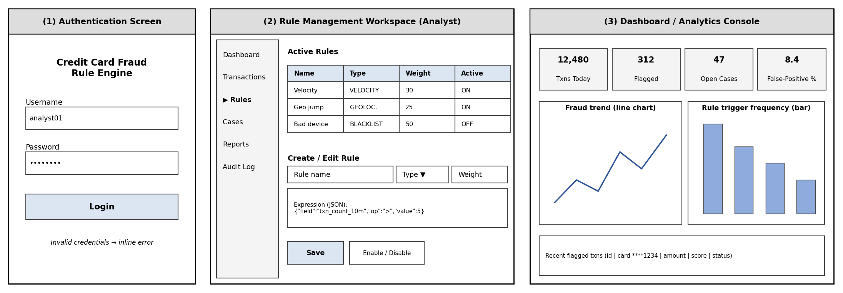
Figure 4.1: User Interface Wireframes – (1) Authentication, (2) Rule Management Workspace, (3) Dashboard

4.2 Hardware Interfaces
Specification of physical interaction points:
- Standard Deployment: Server: x86-64 host or cloud VM (suggested minimum for the demonstration deployment: 2 vCPU, 4 GB RAM). Client: standard keyboard, mouse and display ≥ 1366x768.
- Embedded / IoT Variants: Not applicable. The system has no direct hardware interfaces; POS terminals and ATMs reach it indirectly through the upstream transaction source.
4.3 Software Interfaces
- Relational Database Connector: SQLAlchemy ORM (with Alembic migrations) interfacing with PostgreSQL/MySQL over TCP through the built-in connection pool; credentials supplied through environment variables or a secrets manager.
- External Services: Upstream transaction source (payment gateway / card-network feed or simulator) calling POST /api/transactions; optional Apache Kafka (aiokafka / confluent-kafka-python) for streaming ingestion; optional email/SMS notification service; optional ELK stack for log monitoring.
- Internal Interfaces: Frontend to backend over REST (httpx/requests); backend to rule engine as an in-process call, or a lightweight internal API/gRPC call if the rule engine is externalized. Auto-generated OpenAPI (Swagger UI / ReDoc) documents all endpoints.
Principal REST endpoints (endpoints marked † are proposed additions to those named in the synopsis):
Endpoint | Purpose | Allowed Roles
POST /api/auth/login | Authenticate and obtain a JWT | Public
POST /api/transactions | Submit a transaction for scoring | Transaction Source
GET /api/transactions, /{id} † | Search transactions; transaction detail with triggered rules | Admin, Analyst, Viewer
GET /api/rules | List rules | Admin, Analyst
POST /api/rules; PUT /api/rules/{id} | Create rule; update or enable/disable rule | Admin, Analyst
GET /api/cases; PUT /api/cases/{id} † | List cases; update status, notes, assignment | Admin, Analyst
GET /api/reports/* † | Dashboard and report aggregates | Admin, Analyst, Viewer
/api/users*, GET /api/audit-logs † | User management; audit log viewer | Admin
4.4 Communication Interfaces
- Web Traffic Protocol: HTTPS with TLS 1.2 or higher (TLS 1.3 preferred) between users, API clients, the Streamlit frontend and the FastAPI backend; plain HTTP only inside a private container network.
- Data Serialization: UTF-8 application/json; timestamps in ISO 8601 (UTC); amounts as decimals with ISO 4217 currency codes; JWT sent as an Authorization: Bearer header.
- Streaming (optional): Kafka protocol for the transaction-event topic, using aiokafka or confluent-kafka-python.
5. Non-Functional Requirements (NFRs)
Attribute | Target Metric / Standard | Verification & Testing Method
5.1 Performance | Transaction scoring (request to decision) p95 < 500 ms with 20 active rules at 50 concurrent requests; other API calls < 350 ms; page load < 3 s with 100,000 stored transactions. | Load testing (Locust / JMeter / Apache Benchmark); EXPLAIN analysis of velocity queries.
5.2 Security | BCrypt-hashed passwords; no stored PAN/CVV; TLS for all external traffic; parameterized queries (ORM); RBAC on every endpoint; rate limiting on login and ingestion (default 100 requests/min per client); secrets never in source code. | OWASP ZAP scan; per-role authorization tests (pytest); repository secret scan; PCI-DSS self-assessment checklist.
5.3 Reliability and Recovery | Availability ≥ 98% during the academic evaluation window; no partial writes; automatic process restart; on database failure the API returns HTTP 503 (never a silent approval); scheduled encrypted backups with point-in-time recovery, RTO ≤ 4 h and RPO ≤ 15 min (targets). | Fault-injection tests (kill process, stop database); backup restore drill; Docker restart policy / systemd.
5.4 Data Integrity and Auditability | ACID transactions and foreign-key constraints; 100% of logins, rule changes, case resolutions and user-management actions audited; audit_logs append-only; every decision reproducible from stored rule_evaluations. | Constraint tests; audit-coverage tests; attempted UPDATE/DELETE on audit_logs must fail.
5.5 Usability | A trained analyst can create, edit and enable a rule through the UI without writing code; inline validation messages; consistent navigation; masked card numbers everywhere. | Task-based walkthrough with 3–5 users; UI checklist review.
5.6 Maintainability | Layered architecture; adding a new rule type changes only the rule-evaluator module; ≥ 70% unit-test coverage of the service layer; auto-generated OpenAPI docs; Alembic migrations for every schema change. | pytest-cov report; code review; migration up/down test.
5.7 Scalability | Indexes on card_id, transaction_time, merchant_id, customer_id; transactions table partitionable by date; stateless API that scales horizontally; optional Kafka ingestion. | Load test with ≥ 1 million synthetic transactions; query-plan review.
5.8 Portability | Runs on Linux and Windows through Docker; works with MySQL or PostgreSQL via SQLAlchemy without code changes; supports Chrome, Edge, Firefox and Safari. | Test suite run against both databases; manual cross-browser check.
6. System Design and Analysis Models
University evaluation rubrics require standard graphical analysis models illustrating the dynamic and static behavior of the application:
Diagram Type | Objective & Scope | Deliverable Format
Use Case Diagram | Maps Administrator, Fraud Analyst, Viewer and Transaction Source to use cases UC1–UC12. | Figure 6.1 and use case summary (Table 6.1).
Data Flow Diagram (DFD) | Level 0 (Figure 2.1) and Level 1 decomposition into seven processes and seven data stores. | Figure 6.2 (Gane-Sarson style data stores).
Entity-Relationship (ERD) | Nine entities with primary/foreign keys and relationships from the project schema. | Figure 6.3 (crow's foot notation) with 3NF notes.
Activity / Sequence Diagram | Message sequence for transaction evaluation, including the alt path for flagged transactions and error handling. | Figure 6.4 (UML sequence diagram).
6.1 Use Case Diagram
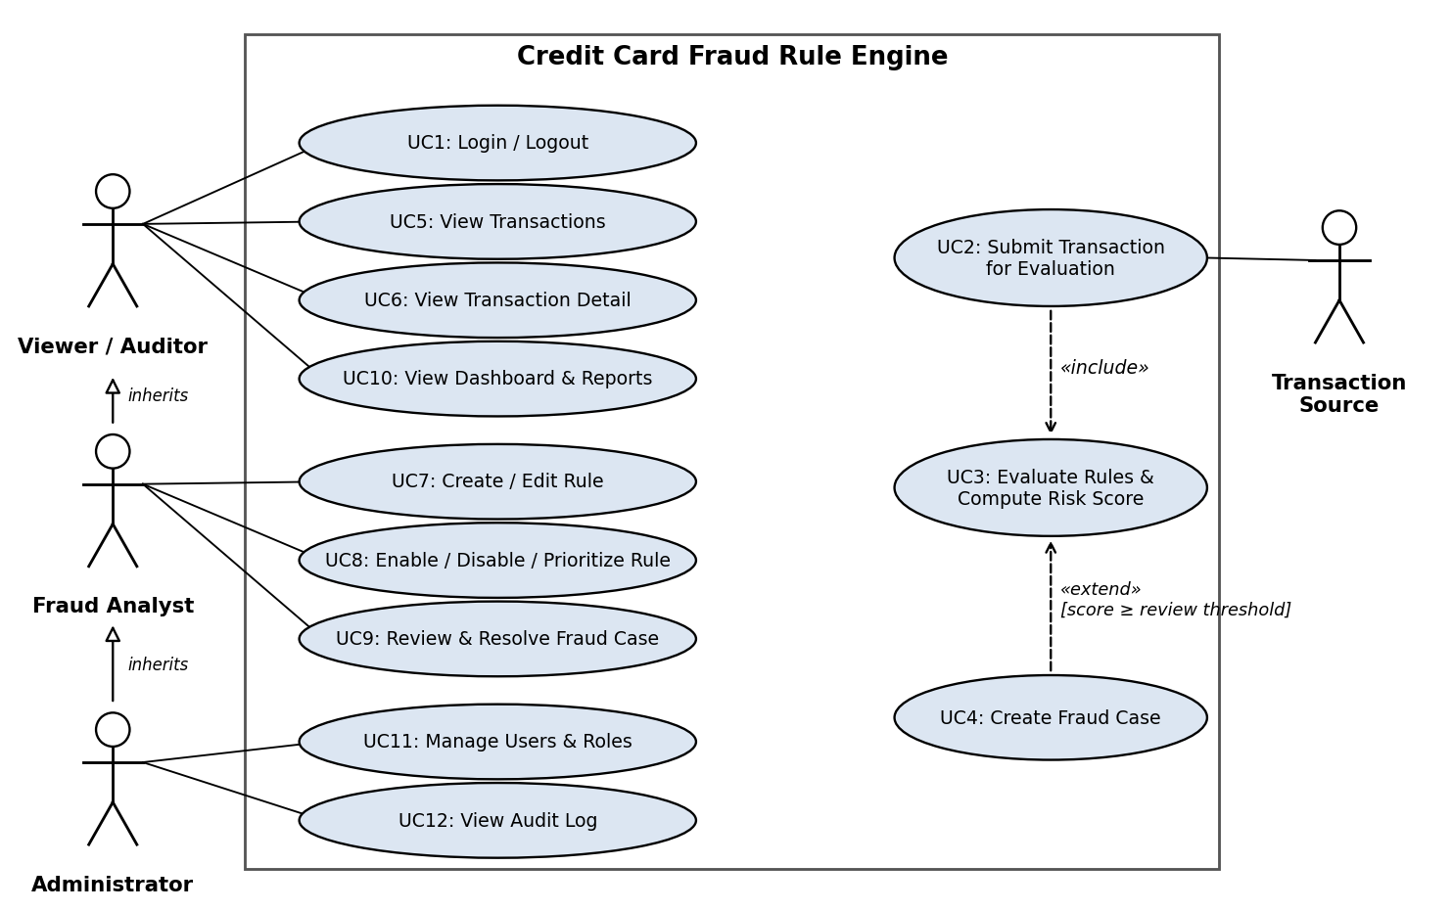
Figure 6.1: Use Case Diagram
Use Case | Primary Actor | Description, Pre-condition and Outcome
UC1 Login / Logout | All users | Pre: active account. Credentials verified and JWT issued; logout invalidates the session.
UC2 Submit Transaction for Evaluation | Transaction Source | Pre: valid service credential; card and merchant known. Outcome: transaction stored with status and risk score; decision returned.
UC3 Evaluate Rules and Compute Risk Score | System (included by UC2) | All active rules evaluated; rule_evaluations stored; weights summed; score mapped to APPROVED / UNDER_REVIEW / DECLINED.
UC4 Create Fraud Case | System (extends UC3) | When status is UNDER_REVIEW or DECLINED, an OPEN fraud case is created and linked to the transaction.
UC5 View Transactions | Viewer (inherited by Analyst, Admin) | Search and filter transactions by date, masked card, merchant, status and score.
UC6 View Transaction Detail | Viewer (inherited) | Shows triggered rules, score contributions and the linked case.
UC7 Create / Edit Rule | Fraud Analyst (inherited by Admin) | Expression validated; takes effect for later transactions; change audited.
UC8 Enable / Disable / Prioritize Rule | Fraud Analyst (inherited by Admin) | Toggles is_active or changes priority/weight; change audited.
UC9 Review and Resolve Fraud Case | Fraud Analyst (inherited by Admin) | Adds notes and moves the case through IN_REVIEW to CLOSED_FRAUD or CLOSED_LEGITIMATE.
UC10 View Dashboard and Reports | Viewer (inherited) | Trend charts, rule trigger frequency, false-positive rate.
UC11 Manage Users and Roles | Administrator | Create, update and deactivate accounts; assign roles; audited.
UC12 View Audit Log | Administrator | Search the immutable audit trail by user, action and date.
Table 6.1: Use case summary
6.2 Data Flow Diagrams
The Level 0 (context) diagram is given in Figure 2.1. Figure 6.2 decomposes the system into seven processes that read and write seven data stores.
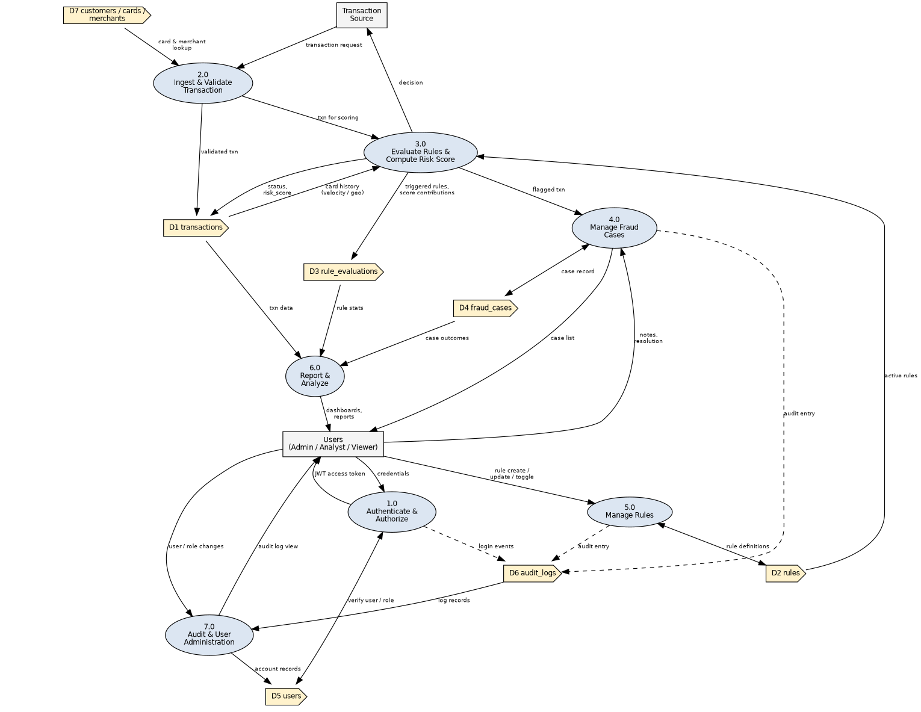
Figure 6.2: DFD Level 1
6.3 Entity-Relationship Diagram
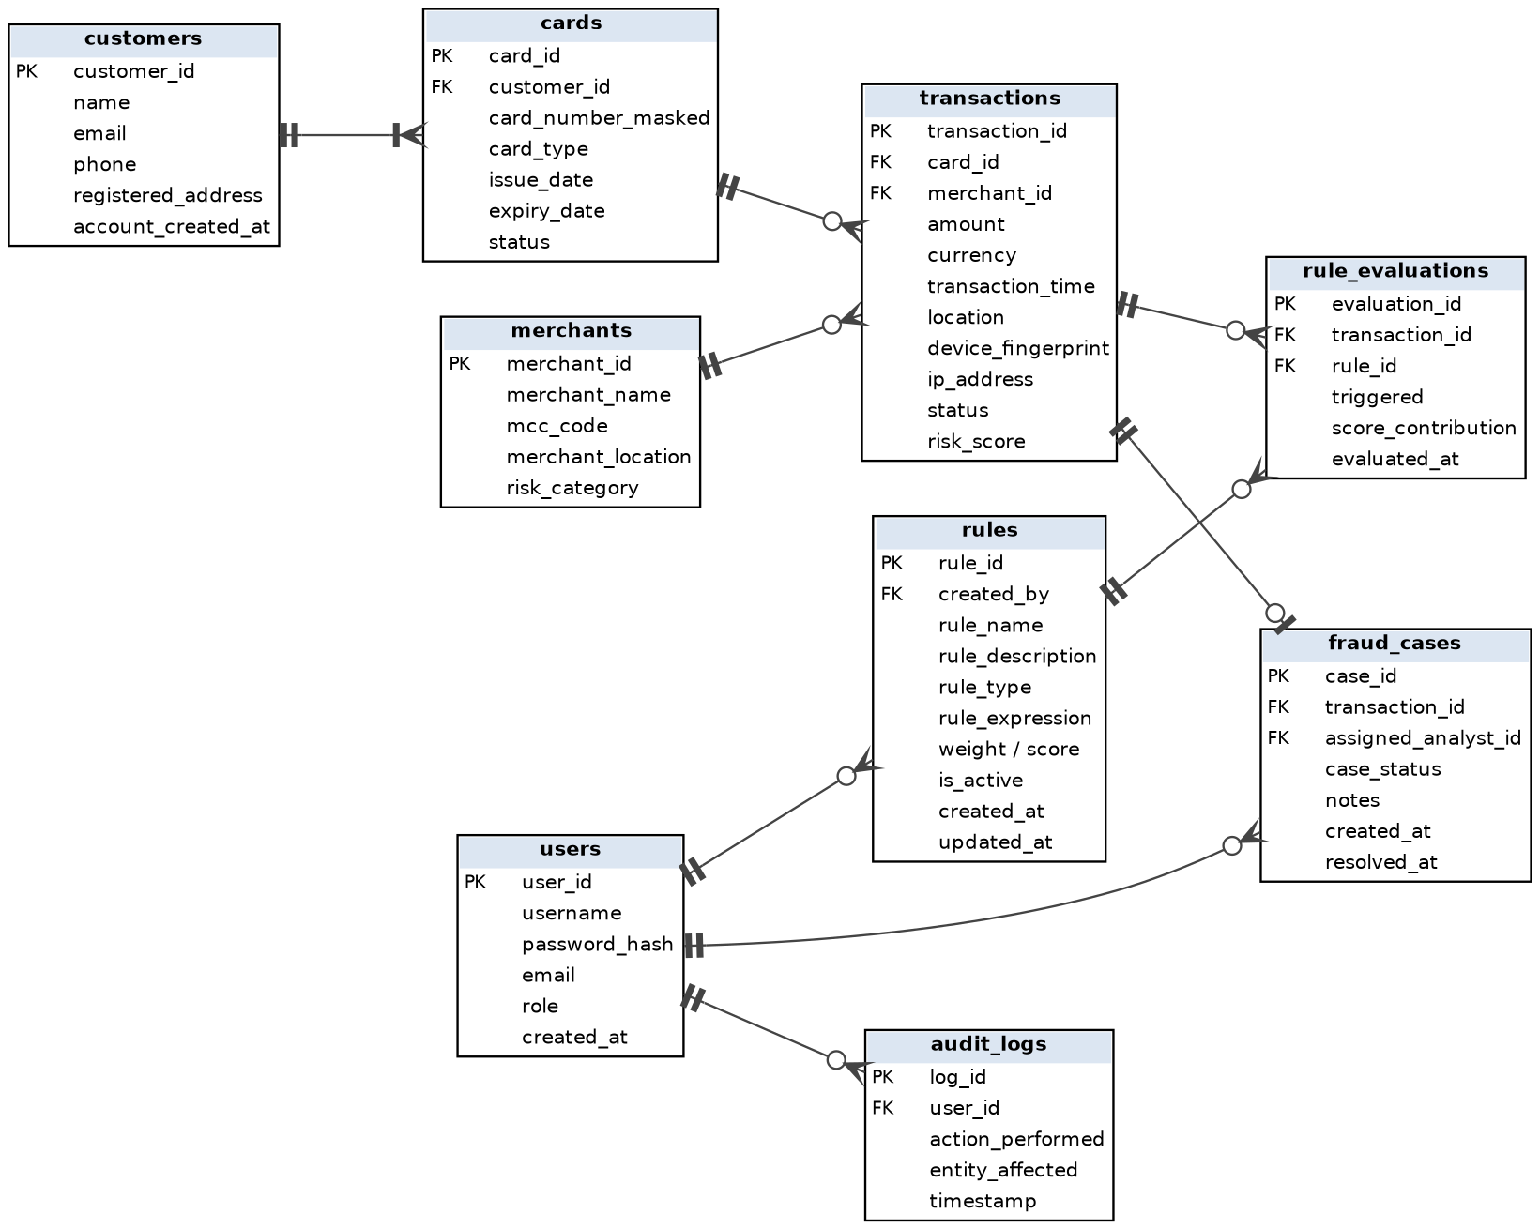
Figure 6.3: Entity-Relationship Diagram (crow's foot notation)
- Relationships: Customer 1:N Card; Card 1:N Transaction; Merchant 1:N Transaction; Transaction M:N Rule resolved through rule_evaluations; Transaction 1:0..1 Fraud Case; User 1:N Fraud Case (assigned analyst); User 1:N Audit Log; User 1:N Rule (created_by).
- Normalization: The schema is in third normal form (3NF): every non-key attribute depends only on its table's key; the many-to-many link between transactions and rules is a separate join table.
- Extensions: The proposed additions listed in Section 2.5 (rule priority, user active flag, threshold configuration, idempotency key) are not drawn; they extend the schema above.
6.4 Sequence Diagram – Transaction Evaluation
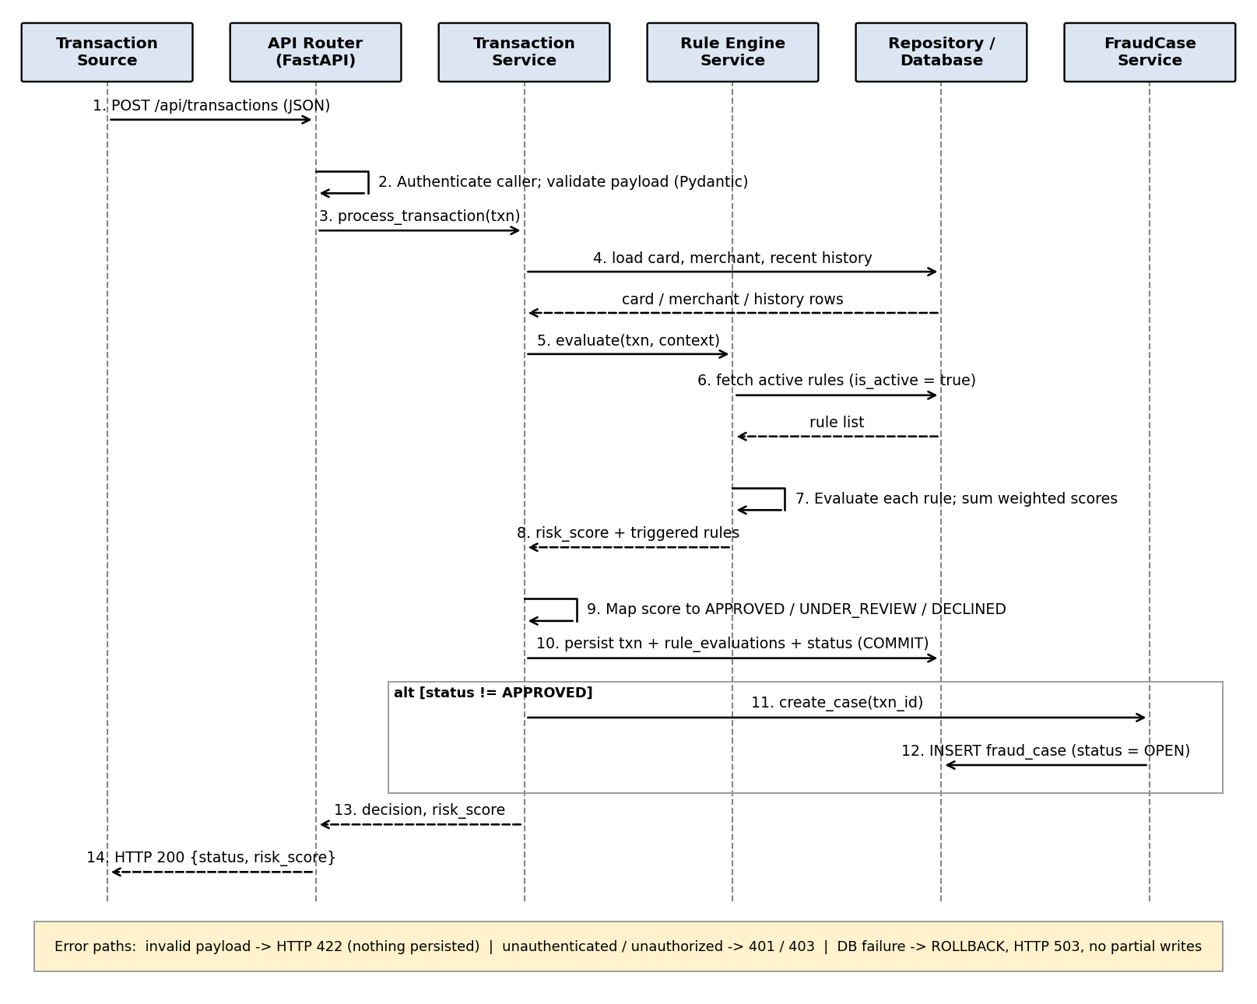
Figure 6.4: Sequence Diagram for POST /api/transactions
Project Repository: https://github.com/angy-es/credit-card-fraud-rule-engine

